The Islamia University of Bahawalpur Department of Information Technology



SOFTWARE DESIGN DESCRIPTION
(SDD DOCUMENT)
for

<E-commerce Web Application>
Version 1.0

By
Muhammad Raees Bashir
Roll No: F22BINFT1M01261
Fall 2022 – 2026

Supervisor
Ms. kainat

Bachelor of Science in Information Technology

Table of Contents
Introduction 1
Design methodology and software process model 1
System overview 3
Design Model 7
1.Class Diagram 7
2. Sequence Diagram 8
3. State Transition Diagram 9
4.Data Flow Diagram(DFD) 11
Data Design: 12
Data Dictionary 13
Algorithm and Implementation 14
Software requirements traceability matrix 20
Human interface design 20
Screen Objects and Actions 21
Appendix 1 21

Revision History

Name | Date | Reason for changes | Version

Application Evaluation History

Comments (by committee)  *include the ones given at scope time both in doc and presentation | Action Taken

Supervised by
<Ms. kainat>

Signature

Introduction
This document specifies the requirements for the Ecommerce Web Application, which will allow users to browse products, manage shopping carts, place orders, and securely make payments. The document serves as a detailed guide for the developers, testers, and stakeholders involved in the system's design, development, and maintenance.

Design methodology and software process model
Explain and justify the choice of design methodology being followed. (OOP or procedural). Also explain which process model are you following and why.

Design Methodology
The project, "Ecommerce Web Application," follows the Object-Oriented Programming (OOP) methodology. This is justified because:
- The application is modular and consists of clearly defined entities like users, products, shopping carts, orders, and payments, which align with the principles of OOP (e.g., encapsulation, inheritance, and polymorphism).
- OOP allows for code reusability through inheritance, making it easier to manage and extend features such as product search, payment integration, and order processing.
- The complexity of the project benefits from OOP’s ability to model real-world entities (e.g., user accounts and products) and relationships between them (e.g., orders contain products).
- The use of modern web technologies like React and Node.js supports an objectoriented approach, as they are designed to handle components and objects efficiently.

Process Model
The project follows the Iterative and Incremental Model, which is justified because:
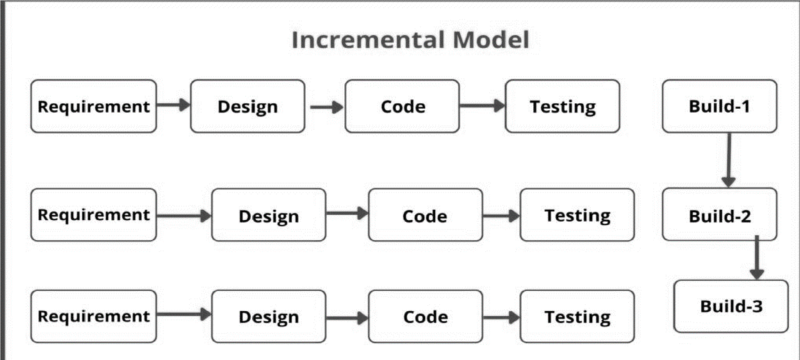
The Incremental Model for software development typically follows a cycle of requirements, design, coding, testing, and building the system incrementally.
- Requirements
In the Requirements phase , the focus is on understanding the core functionality that needs to be delivered first. This could involve:
Identifying Essential Features: For Build , you might only need to implement the most critical or foundational features of the system (e.g., login functionality for a web application).
User Stories: Define simple user stories or requirements, such as "As a user, I want to log into the application securely."
Scope of Build: Establish the boundaries of Build 1 and what will be included. For example, only basic authentication could be implemented in this first iteration.
- Design
The Design phase for Build will focus on how the initial features will be implemented. This might involve:
High-Level Architecture: Defining the architecture for Build 1, such as the database schema, user authentication, and API services.
UI/UX Design: Basic wireframes or mockups for the user interface associated with the login feature, ensuring that the design supports future increments.
Component Design: Deciding on how components like user authentication, session management, and database interaction will be structured.
- Coding
In the Coding phase for the actual implementation of the core functionality will take place. For example:
Authentication Logic: Implement the user login functionality with a database that stores user credentials.
Frontend Interface: Code the user interface that allows users to input their login details (username, password).
Backend Development: Create backend services or APIs that process login requests and validate user credentials.
- Testing
After the coding is done, the Testing phase focuses on ensuring that Build 1 works as expected. This might include:
Unit Testing: Test individual components like the login form, password validation, and API responses.
Integration Testing: Ensure that the login component integrates well with the backend system and the database.
User Testing: Allow end users to test the basic login functionality to ensure it's easy to use and secure.
- Build
Once the requirements, design, code, and tests are complete, Build can be deployed to a staging or production environment. This might involve:
Building the System: Packaging the code and dependencies for deployment.
Deployment: Deploy Build 1 to a server or cloud environment.
Post-Deployment Testing: Conducting final checks in the production environment to ensure everything is working.

System overview
The Ecommerce Web Application is designed to provide an efficient, secure, and userfriendly platform for online shopping. It allows users to browse through products, manage their shopping carts, place orders, and securely process payments. The application is built to cater to the needs of both end-users (customers) and backend administrators, ensuring seamless interaction between the system's components. Functionality
- User Registration and Login: o Users can create accounts and log in using secure credentials. o The system stores and manages user information securely.
- Product Search and Browsing:
o Users can search for products by keywords, categories, or filters (e.g., price range, brand, or size). o Detailed product information is displayed, helping users make informed purchase decisions.
- Shopping Cart Management:
  - Users can add, view, update, and remove products in their shopping cart.
  - The system dynamically calculates the total cost, including taxes and app- licable discounts.
- Order Processing:
  - The system allows users to finalize purchases by entering shipping and payment information.
  - Integration with external payment gateways ensures secure transactions.
- Payment Integration:
  - Supports multiple payment options, including credit cards, PayPal, and Stripe.
  - Complies with PCI-DSS standards for secure handling of payment data.
- Order History and Tracking:

Context
The Ecommerce Web Application operates as a standalone platform accessible through modern web browsers. It integrates with:
- Payment Gateways (e.g., PayPal, Stripe) for secure financial transactions.
- Inventory Management Systems to ensure product availability.
- Shipping APIs (e.g., UPS, FedEx) for delivery tracking.
The system is hosted on a cloud-based infrastructure, ensuring scalability, availability, and optimal performance even during peak traffic periods.
o Users can view their previous orders and track the status of current orders.

Design
The system follows a modular design, with key components such as user authentication, product catalog management, shopping cart, and payment processing separated into distinct modules. This modularity simplifies development, testing, and future updates.

- Frontend:
  - Developed using React, ensuring a dynamic and interactive user interface.
  - Ensures compatibility across devices (desktop and mobile).
- Backend:
  - Built on Node.js for efficient handling of server-side logic and API integrations.
  - Data is managed using MongoDB, a NoSQL database suitable for handling the dynamic nature of ecommerce data.
- Security:
  - Implements role-based access control to protect sensitive data.
  - Encrypts sensitive information such as passwords and payment details.
- System Integration: o The architecture supports smooth integration with third-party APIs for payment and shipping.

Background Information
Ecommerce is a fast-growing industry where user expectations for convenience, performance, and security are high. The application leverages modern web technologies and industry best practices to meet these expectations, ensuring it remains competitive and scalable.

Architectural design
The Ecommerce Web Application follows a multi-tiered architecture that decomposes the system into modular components, ensuring scalability, maintainability, and efficient collaboration between the modules. Below is an overview of the program structure and relationships among the key components:
Modular Program Structure
1. Presentation Layer (Frontend): o Components: User interface (UI) developed using React.
- Functionality:
  - Handles all user interactions.
  - Displays product catalogs, shopping cart, order summaries, and account details.
  - Sends user inputs (e.g., login credentials, product selections) to the backend through APIs. 2. Business Logic Layer (Backend):
- Components: Node.js application with a RESTful API.
- Functionality:
  - Processes user requests and coordinates between the frontend and the database. ▪ Implements core business rules (e.g., order processing, discount calculations). ▪ Manages communication with external APIs (payment gateways and shipping systems).
3. Data Layer (Database):
o Components: MongoDB database. o Functionality:
- Stores and manages structured and unstructured data such as user accounts, product details, order history, and transaction logs.
- Ensures secure and efficient data retrieval for the backend.
4. Third-party Services Integration Layer: o Components: External APIs for payment processing (e.g., creditcard,jazzcash, Stripe) and shipping providers (e.g., UPS, FedEx).
o Functionality:
▪ Handles secure payment transactions and compliance with PCI-DSS standards. Relationships Between Modules
1.Frontend → Backend:
- The frontend communicates with the backend using RESTful APIs, sending requests for data and actions like fetching product lists, adding items to the cart, and processing orders.
2.Backend → Database:
- The backend interacts with the database to query, update, or delete records based on user actions, such as retrieving product details, validating user credentials, or saving order history.
3.Backend → Third-party Services:
- The backend integrates with payment and shipping APIs to process payments and track shipments.
4.Frontend → Backend → Third-party Services: ▪ For operations like payment processing, the frontend sends payment details to the backend, which then communicates securely with the payment gateway to complete the transaction Facilitates real-time order tracking and inventory updates through external APIs.
Collaboration to Achieve Functionality
- When a user searches for a product, the frontend sends the query to the backend, which retrieves matching products from the database and returns the results for display.
- When a user places an order, the backend processes the shopping cart details, validates the payment using the payment gateway, updates the database, and sends the order confirmation to the frontend.
- For order tracking, the backend communicates with the shipping API, retrieves tracking information, and provides it to the frontend for user display

Process flow/Representation
Provide a representation of the flow of Major processes of your system in the form of an activity diagram.

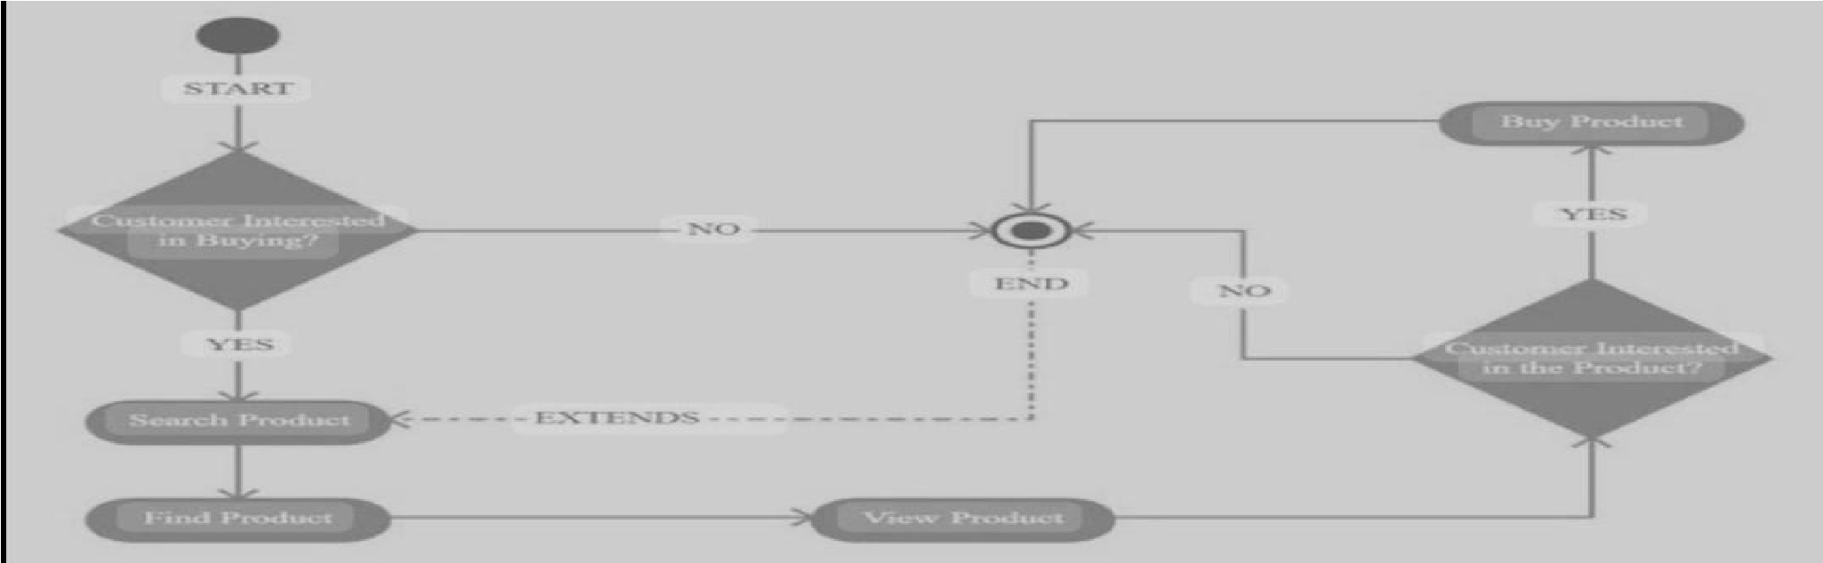

The customer begins by searching for a product on the e-commerce platform, using filters or keywords to narrow down options. Upon finding a product, they view detailed information including descriptions, specifications, prices, and reviews. If interested, they add the item to their shopping cart. After reviewing the cart, they proceed to checkout, where they enter shipping details, choose a payment method, and confirm the order. The platform processes the payment, confirms the order, and sends a receipt. The product is shipped to the customer, who receives it along with post-purchase support for returns, exchanges, or inquiries.

Design Model

1.Class Diagram
This is suitable for an object-oriented approach and represents the static structure of the system by showing the system's classes, their attributes, methods, and relationships.
Key Features:
- Classes:
  - User: Attributes include userID, username, email, password. o Product: Attributes include productID, name, category, price, stock. o Order: Attributes include orderID, orderDate, totalAmount, status. o Payment: Attributes include paymentID, method, transactionID, amount.
  - Cart: Attributes include cartID, items, totalPrice.
- Relationships:
  - Aggregation between User and Order (a user can place multiple orders). o Composition between Cart and Product (a cart contains products). o Inheritance between Payment and specific payment methods (e.g., CreditCard, e-wallet ,jazzcash,etc ).
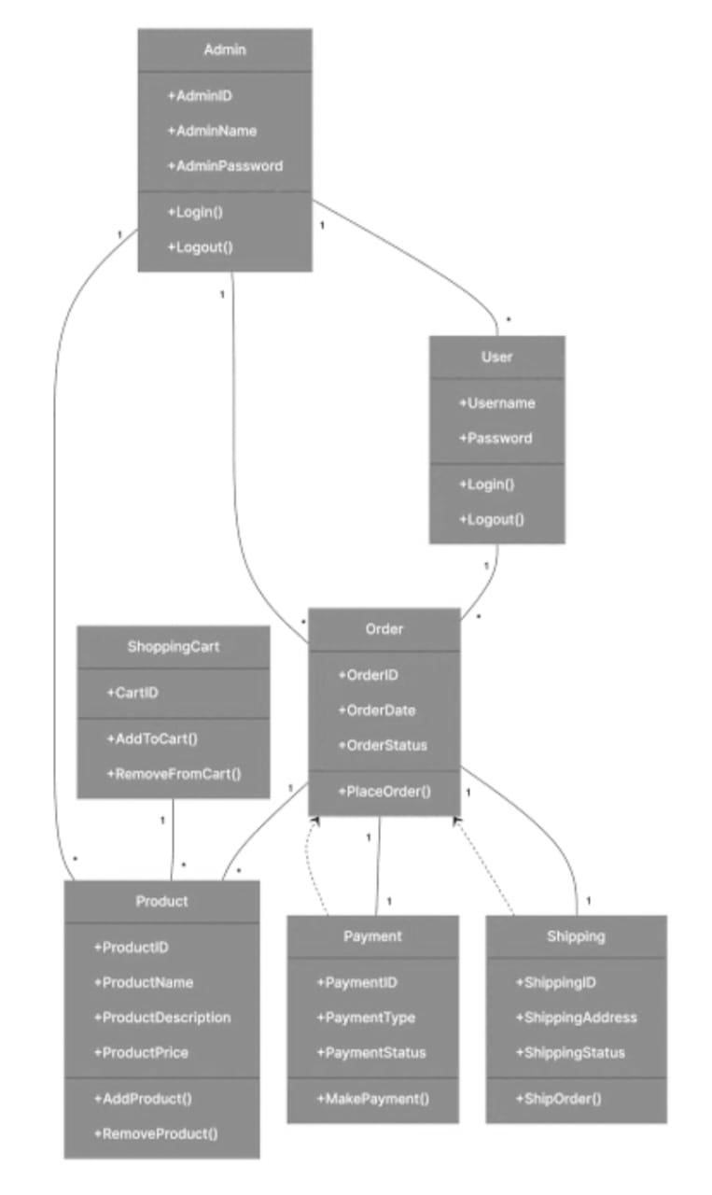

2. Sequence Diagram

Illustrates how objects interact in a particular scenario of a use case.
Example: Purchase Product
- Actors: Customer, Ecommerce System, Payment Gateway.
- Steps:
  - Customer selects a product and adds it to the cart.
  - Customer views the cart and proceeds to checkout.
  - System displays the order summary.
  - Customer enters payment details.
  - System sends payment request to the Payment Gateway.
  - Payment Gateway confirms the transaction.
  - System updates the order status and sends a confirmation email.
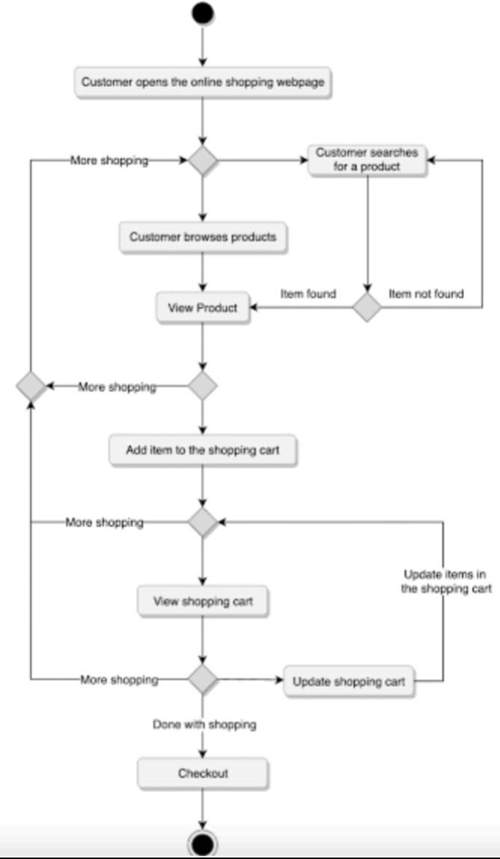

3. State Transition Diagram
Describes the states an entity (like an order) goes through during its lifecycle. Example: Order Lifecycle
- States:
  - Order Created: Initial state when an order is initiated. o Payment Processing: Order is being processed for payment.

  - Order Confirmed: Payment is successful, and the order is confirmed. o Order Shipped: Order is handed over to the shipping partner. o Order Delivered: Order is delivered to the customer.
  - Order Cancelled: Order is cancelled due to payment failure or user request.
- Transitions:
  - Order Created → Payment Processing: Triggered when the user clicks "Proceed to
Checkout." o Payment Processing → Order Confirmed: Triggered on successful payment. o Order Confirmed → Order Shipped: Triggered when the order is dispatched. o Order Shipped → Order Delivered: Triggered on delivery confirmation.

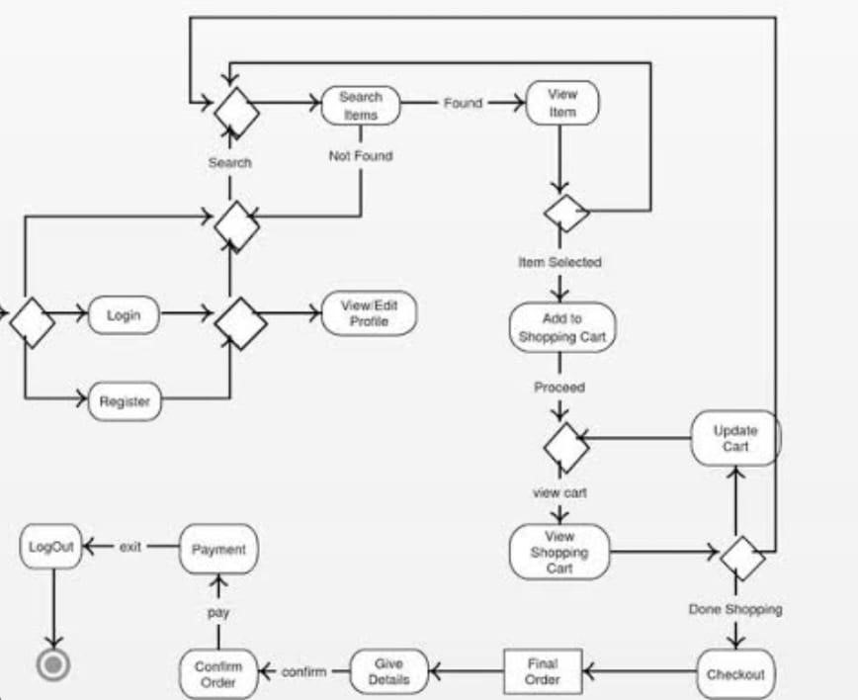

4.Data Flow Diagram(DFD)
Depicts the flow of data within the system. This should include multiple levels for detailed clarity. Level 0: Context
- Processes:
  - User Registration o Product Search o Order Processing o Payment Integration
- Sources/Sinks:
  - Users (Input: Login details, Output: Order confirmation, etc.) o Payment Gateway (Input: Payment details, Output: Payment status) o Inventory System (Input: Product requests, Output: Stock updates)
Level 1: Detailed DFD
- Expands Order Processing:
  - Input: Cart details, payment information. o Processes: Validate cart, calculate total, process payment.
  - Output: Order confirmation, stock adjustment.
- Expands Product Search:
  - Input: Search query, filters. o Processes: Query database, retrieve results. o Output: Product list.
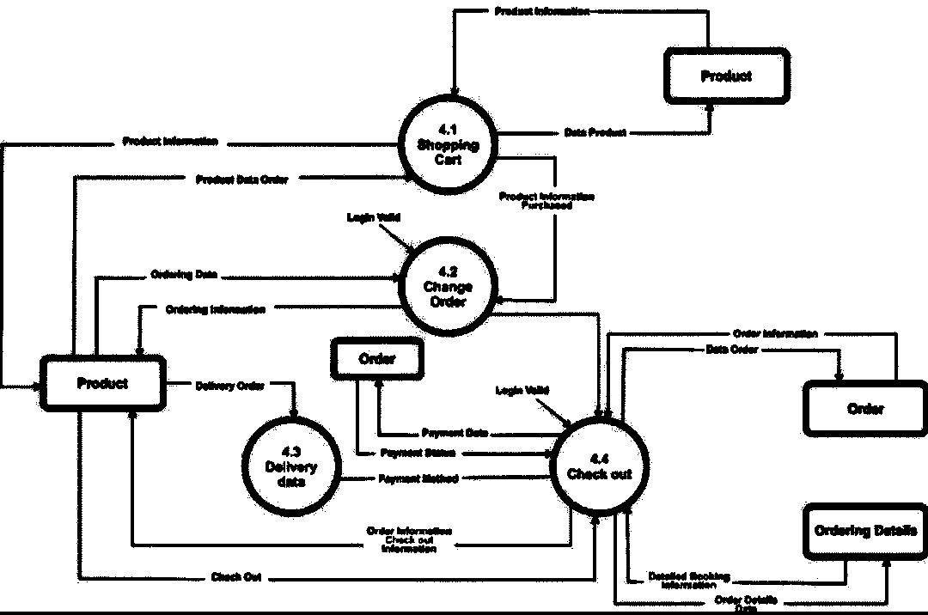

Data Design:
Information Domain Transformation into Data Structures
In an Ecommerce Web Application, the information domain revolves around users, products, orders, and payment processing. The transformation of this domain into data structures follows these steps:
- Entities Identified: Key entities are derived from the system's information requirements, such as users, products, orders, payments, and carts.
- Attributes Assigned: Each entity is associated with attributes that store relevant data (e.g., a User entity has attributes like username and email).
- Data Relationships Defined: Relationships such as one-to-many (e.g., one user can have multiple orders) or many-to-many (e.g., products in multiple orders) are modeled.
- Database Schema Designed: The entities and relationships are translated into tables or collections, depending on the database type.
Optimization: Indexes, primary keys, and foreign keys are added to optimize querying and ensure data integrity. Data Storage Mechanism
Databases or Data Storage Items:
- Database Type: MongoDB (NoSQL database) for its flexibility in storing nested and hierarchical data.
- Collections (Tables):
  - Users Collection:
    - Stores user-related information like login credentials, profile data, and preferences.
  - Products Collection:
    - Stores product details such as names, categories, prices, stock levels, and images.
  - Orders Collection:
    - Tracks orders placed by users, including items ordered, total amount, and order status.
  - Payments Collection:
    - Logs payment details, transaction statuses, and methods.
  - Cart Collection:
    - Temporary storage for user-selected items before checkout.
Storage Process:
- CRUD Operations:
o Create: New users, products, and orders are added. o Read: Querying products, retrieving user details, and fetching orders. o Update: Updating order statuses, product stock levels, or user profiles. o Delete: Removing items from carts or cancelling orders.

Data Dictionary
Here is an alphabetical list of system entities, their attributes, and their descriptions:
Entities and Attributes:
- Cart: o cartID (String): Unique identifier for the cart. o userID (String): Identifier of the user owning the cart.
  - items (Array): List of items in the cart with quantity and product IDs.
  - totalPrice (Number): Total price of all items in the cart.
- Order: o orderID (String): Unique identifier for the order. o userID (String): Identifier of the user placing the order. o items (Array): List of purchased products and quantities.
  - totalAmount (Number): Final amount paid.
  - status (String): Status of the order (e.g., "Processing", "Shipped").
- Payment:
  - paymentID (String): Unique identifier for the payment.
  - orderID (String): Identifier of the associated order.
  - method (String): Payment method used (e.g., "Credit Card", "PayPal"). o transactionID (String): Unique identifier for the transaction.
  - amount (Number): Amount paid.
- Product:
  - productID (String): Unique identifier for the product.
  - name (String): Name of the product.
  - category (String): Category of the product. o price (Number): Price of the product. o stock (Number): Quantity available.
  - description (String): Details about the product.
- User:
  - userID (String): Unique identifier for the user. o username (String): Name chosen by the user. o email (String): User's email address. o password (String): Encrypted password.
  - address (String): User's delivery address.
Functions and Parameters (For Functional Description):
- registerUser(username, email, password):
  - Registers a new user and returns the userID.
- searchProduct(keyword, filters):
  - Searches for products based on keywords and returns matching items. 3. addToCart(userID, productID, quantity):
  - Adds a product to the user’s cart.
- checkoutCart(userID, paymentDetails):
o Processes the checkout for a user’s cart.
- trackOrder(orderID):
Fetches the status of a user’s order. Objects and Methods (For Object-Oriented Description):
- User:
  - Methods:
    - register()
    - login() ▪ updateProfile()
- Cart:
  - Methods:
    - addItem(productID, quantity)
    - removeItem(productID)
    - calculateTotal()
- Order:
  - Methods:
    - createOrder(userID, items, totalAmount)
    - updateStatus(orderID, status)
    - viewOrderDetails(orderID)
- Payment:
  - Methods:
    - processPayment(orderID, method, amount)
    - refund(transactionId)

Algorithm and Implementation
Procedural Description Language (PDL)

Functions and Algorithms (For Functional Description)
- registerUser(username, email, password)
Purpose: Registers a new user by storing their credentials securely.
plaintext Copy code
Input: username, email, password
Output: userID

Algorithm:
  - Check if the email already exists in the database.
  - If email exists, return an error message.
  - Otherwise:
    - Encrypt the password using a secure hashing algorithm.
    - Generate a unique userID.
    - Save username, email, encrypted password, and userID in the database.
  - Return the userID.
- searchProduct(keyword, filters)
Purpose: Searches for products based on a keyword and optional filters (e.g., price range, category).
plaintext Copy code
Input: keyword, filters (optional)
Output: List of matching products

Algorithm:
  - Query the database for products matching the keyword.
  - If filters are provided:
    - Apply each filter to refine the results (e.g., price, category).
- Sort the results by relevance or a default criterion (e.g., price or popularity).
- Return the list of matching products.
- addToCart(userID, productID, quantity)
Purpose: Adds a product to the user's cart.
plaintext Copy code
Input: userID, productID, quantity
Output: Success/Failure message

Algorithm:
  - Check if the productID exists in the database.
  - Verify the requested quantity is less than or equal to the available stock.
  - If valid:
    - Retrieve the user’s cart from the database.
    - Add the productID and quantity to the cart.
    - Update the cart's total price.
    - Save the cart to the database. 4. Return a success message.
5. If any step fails, return an appropriate error message.
- checkoutCart(userID, paymentDetails)
Purpose: Processes payment and creates an order for the user’s cart.
plaintext Copy code
Input: userID, paymentDetails
Output: Order confirmation

Algorithm:
  - Retrieve the user's cart from the database.
  - Calculate the total price of the cart.
  - Process the payment using the provided paymentDetails.
    - If payment succeeds:
      - Create a new order record.
      - Deduct the purchased quantities from the product stock. iii. Clear the user's cart. iv. Save the order in the database.
v. Return an order confirmation message.
    - If payment fails, return a payment failure message.

5. trackOrder(orderID)
Purpose: Fetches the status of an order.
plaintext Copy code
Input: orderID
Output: Order status

Algorithm:
- Query the database for the order matching the orderID.
- If the order exists:
a. Retrieve and return the order status.
- If the order does not exist, return an error message.

Object-Oriented Description
Below is the PDL for object member functions for the main objects

User Object
Attributes: userID, username, email, password, address.

1. register()
plaintext Copy code
Input: username, email, password
Algorithm:
- Check if the email exists in the system.
- If not, encrypt the password and save user data in the database.

2. login()
plaintext Copy code
Input: email, password
Algorithm:
- Check if the email exists in the database.
- Verify the provided password matches the stored password.
- If valid, return the userID.

3. updateProfile()
plaintext Copy code
Input: userID, updatedData
Algorithm:
- Retrieve the user record using userID.
- Update the record with the provided data.
- Save changes to the database.

Cart Object
Attributes: cartID, userID, items, totalPrice.
1. addItem(productID, quantity)
plaintext Copy code
Input: productID, quantity
Algorithm:
- Verify product exists and is in stock.
- Add the product and quantity to the cart.
- Update the total price of the cart.

2. removeItem(productID)
plaintext Copy code
Input: productID
Algorithm:
- Locate the product in the cart.
- Remove the product from the items list.
- Recalculate the total price of the cart.

3. calculateTotal()
plaintext Copy code
Input: None
Output: Total price
Algorithm:
- Sum up the prices of all items in the cart based on their quantities.
- Return the total price.

Order Object
Attributes: orderID, userID, items, totalAmount, status.
- createOrder(userID, items, totalAmount)
plaintext Copy code
Input: userID, items, totalAmount
Algorithm:
  - Generate a unique orderID.
  - Save the userID, items, and totalAmount in the order record.
  - Mark the initial status as "Processing."
- updateStatus(orderID, status)
plaintext Copy code
Input: orderID, status
Algorithm:
  - Locate the order using the orderID.
  - Update the status field with the new status.
- viewOrderDetails(orderID)
plaintext Copy code
Input: orderID Output: Order details
Algorithm:
  - Retrieve the order record using the orderID.
  - Return all details of the order.

Payment Object
Attributes: paymentID, orderID, method, transactionID, amount.
1. processPayment(orderID, method, amount)
plaintext Copy code
Input: orderID, method, amount
Algorithm:
- Connect to the payment gateway.
- Process the payment using the method and amount.
- If successful, generate a transactionID and save payment data.

2. refund(transactionID)
plaintext Copy code
Input: transactionID
Algorithm:
- Locate the transaction in the payment records.
- Reverse the transaction and mark it as refunded

Software requirements traceability matrix
Table 7 Requirements Traceability Matrix
Req. Number | Ref. Item | Design Component | Component Items
FR01 | Class Diagram | User | register(), login(), updateProfile()
FR02 | Class Diagram | Product | searchProduct(), calculateStock()
FR03 | Class Diagram | Cart | addItem(), removeItem(), calculateTotal()
FR04 | Sequence Diagram | Checkout Flow | checkoutCart(), createOrder(), processPayment()
FR05 | Data Flow Diagram | Level 0 (DFD) | User registration, Product Search
FR06 | Data Flow Diagram | Level 1 (DFD) | Add to Cart, Checkout  Process
FR07 | State Transition Diagram | Order Lifecycle | createOrder(), updateStatus(), cancelOrder()
FR08 | Sequence Diagram | Payment Integration | processPayment(), refund()
NFR01 | DFD | Level 1 and 2 | Secure communication  (HTTPS)
NFR02 | Class Diagram | User | encryptPassword()
NFR03 | Data Flow Diagram | Level 2 (DFD) | Query optimization for performance
NFR04 | State Transition Diagram | Order Lifecycle | handleExceptions(), notifyUser()

Human interface design
System Functionality from the User’s Perspective
The Ecommerce Web Application offers an intuitive interface that allows users to interact with the system to complete all core functionalities efficiently. The design prioritizes usability, accessibility, and feedback to ensure a smooth user experience. User
Journey and Features
- User Registration and Login:
  - The user can register by providing their username, email, and password. o Login enables access to personal features like order history and saved preferences. _{o} Feedback: Error messages for invalid inputs (e.g., “Email already exists” or “Incorrect password”).
- Product Search and Browsing:
  - The search bar enables keyword-based search.
  - Users can filter results by price range, category, and popularity.
  - Feedback: Displays a list of matching products or "No products found" if no results.
- Shopping Cart:
  - Users can add products to the cart, view their cart, adjust quantities, or remove items. o The cart dynamically updates the total price as items are added or removed.
  - Feedback: "Item added successfully" or "Item removed" notifications.
- Checkout Process:
  - Users can review the order summary, enter shipping details, and complete payment.
  - Supports multiple payment methods, including credit cards and PayPal.
  - Feedback: Displays confirmation upon successful payment or error messages for failed transactions.
- Order Tracking:
  - The user can track order status (e.g., “Processing,” “Shipped,” “Delivered”).
  - Feedback: Displays estimated delivery dates and shipping updates.
- Profile Management:
  - Users can update their profile details, change passwords, and view order history. o Feedback: Confirms updates with success messages.

Screen Objects and Actions
Objects:
- Buttons:
  - Examples: "Login," "Add to Cart," "Checkout." o Actions: Perform corresponding tasks (e.g., adding items to the cart).
- Text Fields:
  - Examples: Search bar, form fields (username, email, etc.).
  - Actions: Accept user input.
- Lists/Tables: o Actions: Display dynamic data and allow interaction (e.g., quantity adjustments).
- Dropdowns/Selectors:
  - Examples: Filters for price range, categories, and payment methods. o Actions: Refine user selections.
Actions:
- Click: Triggers tasks (e.g., submitting forms, navigating to another page).
- Input: Accepts user data.
- Selection: Allows choosing options (e.g., filter criteria or payment method).

Appendix 1
- E-commerce: A business model for buying and selling goods/services over the internet.
- SKU(Stock Keeping Unit): A unique identifier for each product in inventory.
- Payment Gateway: A service that facilitates online payment securely.
- Entity-Realtionship Diagram(ERD): A visual representation of the database schema.
- Books,research papers, and articles referenced in the design process.

